## **NATINAL ARTIFICIAL INTELLIGENCE DAY**

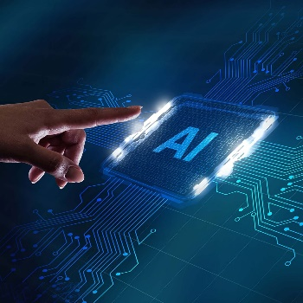

The National 'Ai' Day, celebrated on April 26, you'll get to learn about the meaning behind this Chinese and Japanese word. 'Ai' means 'adoration,' 'affection,' or 'love.

* **HISTORY OF AI**

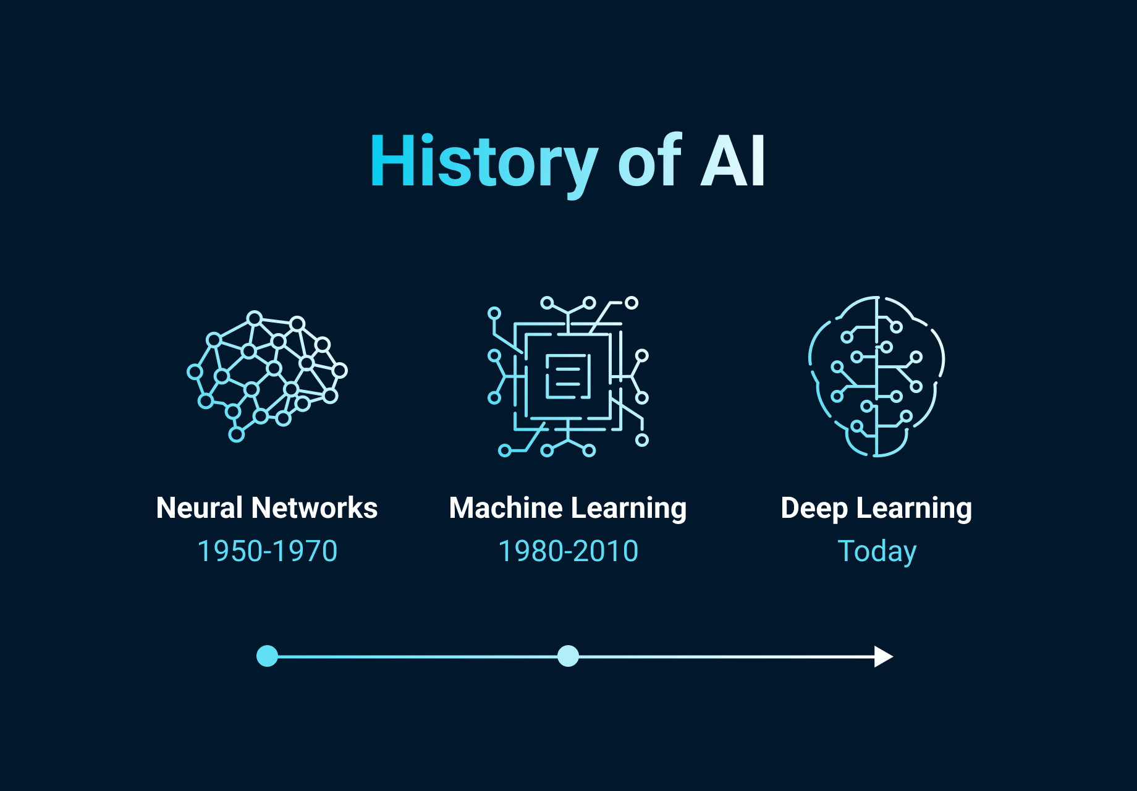The history of artificial intelligence (AI) began in antiquity, with myths, stories and rumors of artificial beings endowed with intelligence or consciousness by master craftsmen. The seeds of modern AI were planted by philosophers who attempted to describe the process of human thinking as the mechanical manipulation of symbols. This work culminated in the invention of the programmable digital computer in the 1940s, a machine based on the abstract essence of mathematical reasoning. This device and the ideas behind it inspired a handful of scientists to begin seriously discussing the possibility of building an electronic brain.

The field of AI research was founded at a workshop held on the campus of Dartmouth College, USA during the summer of 1956.Those who attended would become the leaders of AI research for decades. Many of them predicted that a machine as intelligent as a human being would exist in no more than a generation, and they were given millions of dollars to make this vision come true.

Eventually, it became obvious that researchers had grossly underestimated the difficulty of the project. In 1974, in response to the criticism from James Lighthill and ongoing pressure from congress, the U.S. and British Governments stopped funding undirected research into artificial intelligence, and the difficult years that followed would later be known as an "AI winter". Seven years later, a visionary initiative by the Japanese Government inspired governments and industry to provide AI with billions of dollars, but by the late 1980s the investors became disillusioned and withdrew funding again.

Investment and interest in AI boomed in the 2020s when machine learning was successfully applied to many problems in academia and industry due to new methods, the application of powerful computer hardware, and the collection of immense data sets.

* **FEATURES OF AI**

**1. Eliminate Dull and Boring Tasks**

All of us have, at some point, accomplished a certain task just because we had to do it, not because we enjoyed doing it. We found that task to be boring, or dull. However, with a machine, you never have to experience similar bored ness.

An artificially intelligent system will do and continue doing the task as commanded to it, no matter how many times it has to do it. Also, such systems only make tedious, vast tasks easier for the users.

Let’s take, an **example of AI**, **Dialog flow** which is a subsidiary company of Google, that takes credit for creating the Google assistant. We give so many commands to this assistant in a single day! From asking Ok Google, call mom, to Ok Google, order sandwiches – the assistant has it all covered.

At the same time, we have the facility of being able to send numerous calendar invitations to people using this assistant. All we’ve got to do is choose the time of a certain event, and type in the list of guests. The assistant does the rest of the work.

An invite will be sent to all those on the guest list. This is so much easier when compared to calling, texting, or visiting people to invite them in your event.

### **2. Data Ingestion**

Data ingestion is one of the most important features of artificial intelligence. Artificially intelligent systems deal with huge amounts of data. Even a small company of about 50 employees has huge chunks of data to analyse, we can’t even imagine the quantity of data that organizations like Facebook handle.

Also, an artificially intelligent system stores multiple information about multiple entities from multiple sources. All of this appears on the system in a synchronous, or a simultaneous manner. The data that we are all producing is growing exponentially, which is where AI steps in. Such data is dynamically updated and it becomes difficult for regular database systems to ingest it all. So, AI-enabled systems have gone beyond and gathered and analysed data that can prove to be useful for all. One such **example of artificial intelligence** would be Equify which is basically a database of multiple business contacts. Equify works on a basic principle – give, to receive.

The user has to create an account here and sign in, after which the information of the user’s contacts is accessible and shareable by the system. In return, the user gets relevant business contacts, which might be potential customers. In other words, Equify is crowdsourcing this data.

This explains so much about the coaching centre that first call your friend, then you, and then other friends of yours belonging to the same batch.

### **3. Imitates Human Cognition**

We call it an artificially intelligent system because it essentially imitates or mimics the way the human mind thinks and solves problems. This is what makes AI unique.

Like the humans study their environment, draw inferences, and then interact with it accordingly, an AI also successfully attempts to interpret the environment and act suitably.

However, it is not entirely possible, as of today, but developers and scientists are working on systems that cater to the theory of mind and self-awareness of the artificially intelligent systems.

This further makes us think of the day when an AI system will be able to fully mimic the human mind and behave exactly like a human.

To be honest, I am so looking forward to the day when only my personal AI system will interact with people in my stead, and an asocial me would binge watch some web series in the comfort of my home.

**For example**,**Baidu**, a Chinese tech giant, which is actually a search engine that works in the Chinese language, primarily for the citizens of China.

Baidu also has a voice cloning tool, which can now clone human voice with the help of just 3-4 seconds of audio, as opposed to the previously taken 30 minutes. Well, it is equally terrifying as is awesome!

### **4. Futuristic**

AI-enabled systems are designed to observe and react to their surroundings. They not only perceive the environment and take actions accordingly but also keep in mind (isn’t it ironic that I just used ‘mind’ for artificial intelligence?) the situations that might come up in the near future.

The classic example of this characteristic would be a self-driven car. It notes the speed of the cars that are driving around and tries implementing similar speed patterns in the traffic, also known as **neural networks.**

Simultaneously, it feeds data into the ***machine learning algorithms*** and observes when and how a car is changing lanes. It tries reaching a certain target or goal by considering multiple scenarios.

One must keep in mind that such decisions rely heavily on the**Automated Driving System (ADS)** that is integral to the working of a self-driven car.

ADS, in simple words, is basically a system that uses a combination of various systems that a driver uses to drive the car. With the help of ADS, a car can navigate without the actual presence of a driver inside.

BMW is an example of AI – self-driven cars, a leading German multinational automobile manufacturer is developing self-driven cars that have fully automated driving, however, the driver can still request control from the vehicle at times.

This car will be able to handle most driving situations on its own, giving the driver a break.

### **5. Prevent Natural Disasters**

We are all friendly with using AI for our businesses, for our gaming profiles, and more such purposes. Now it is our turn to take AI one step ahead and hone it, so that governments can use it in disaster management.

Artificially intelligent systems, when fed with data about thousands of previous disasters, AI can accurately predict the future relating to the disasters that might occur. Today, with the help of features of artificial intelligence like these scientists are studying more than a lack of previously occurred earthquakes and similar disasters like tremors and volcanic eruptions, to create a **neural network.**

The mechanism of this network was tested on about 30,000 events, and the predictions of the system came out to be more precise as compared to the traditional techniques.

Similarly, AI systems are studying **seismic information**, which is information regarding movements in the tectonic plates that reside beneath the earth’s surface.

Scientists are also observing ash particles that arise from lava that generates in a volcanic eruption, and other geological information to predict sudden eruptions.

Likewise, we are working on accurately predicting other natural disasters like cyclones, floods, etc.

Cyclone Fani hit Bangladesh and the south eastern state of India- Odisha in May 2019. The Indian Meteorological Department predicted and tracked this storm beforehand and evacuated about 1.2 million residents of Odisha on time, and moved them to cyclone shelters built on higher altitudes.

This helped save numerous lives, and the death toll due to the cyclone was reduced to mere 72 people.

One can only imagine the amount of people whose lives AI can save if these predictions are true and have proper execution.

### **6. Facial Recognition and Chatbots**

Facial recognition system enables a machine to unlock or provide authorized access to an individual, by verifying or identifying a person’s face.

A camera fit into the machine senses the face, and it is compared to a previously stored face in its memory. Most smartphones these days provide facial recognition to unlock the phone.

My friends are notorious and don’t stop pulling pranks on me. One day, I accidentally revealed my phone’s password to them.

Afraid that they would mess up, I simply changed the security setting from password to facial recognition. Now, only I am able to unlock my phone and this has saved me from any kind of embarrassment

Chatbots are software that enables a conversation with the user to solve any issues that they are facing, via auditory methods or texting.

This software simulates human behaviour while talking to a human over an application. Many companies have started using chatbots as a means of customer service, like Swiggy and Nyika.

Swiggy chatbots offer services revolving around issues that the customers face when their food is stuck in traffic, or the items they ordered are unavailable. The Nyika chatbot exists to provide product suggestions to the users.

Top of Form

* Bottom of Form

## **USES OF AI**

* 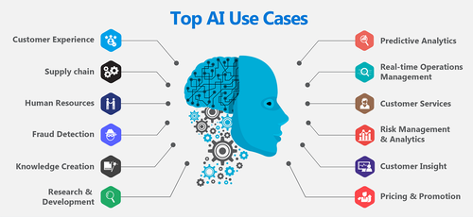Online shopping and advertising
* Web search
* Digital personal assistants
* Machine translations
* Smart homes, cities and infrastructure
* Cars
* Cybersecurity